REPORT

NARRATIVE
Since the mid 1980s the most common interaction between banks and their customers has been through Automated Teller Machines (ATMs). Today there are approximately 3 million ATMs in daily use globally, used to withdraw funds and make queries about customers accounts. With populations growing world-wide, and customers starting to use these bank services at younger ages, the demand for efficient and secure ATM systems has never been higher.

Due to sensitive nature of the information stored in these accounts, and the risk associated with the ability to perform transactions on the go, efficiency and security are key goals of good ATM systems. Protecting customer data is a primary concern of an ATM system, and the NetCash implementation will offer a secure manner to perform these transactions.

NetCash aims to provide the operations of one of these ATMs, with the added ability to transfer funds from one account to another. This added functionality will give customers more freedom to bank on the go with ease, while also reducing the cost to the bank themselves. The benefit is two-fold, as not only will it require less work to be done face-to-face on the premises of the bank, but with the ability to perform these complicated operations outside of the bank the experience for customers who have to converse with the cashier their experience will be more efficent, as more work can be done outside the premises.

SLC
We considered the advantages and disadvantages of 3 of the main Software Life-Cycle models when approaching the design and development of our software, the V-model, the Waterfall model, and Rational Unified Process.

Waterfall: Although the Waterfall model is simple to understand and implement, and clearly defines progress throughout the development of software, this model would restrict our ability to make changes to the requirements and design once we began building and testing our software.

V-model: Again, this models simplicity also leads to an overly rigid and linear development approach. We need our approach to be more dynamic as the inability to produce working code until late in the development presents serious risks.

Rational Unified Process (RUP): The RUP approach appeals to us, as it allows a certain degree of concurrency between the different phases of the SLC, while still providing a sensible structure for iterative and incremental development. Our implementation of this model differs slightly from the standard model due to time constraints, as we will have less iterations, with more of a possibility to work through multiple phases simultaneously.

USE CASES

Login
Actor Action | System Response
 | 1. System prompts the user to enter Account Number.
2. User enters Account Number | 3. System prompts the user to enter PIN.
4. User enters PIN | 5. Login details are verified, the user can now access their account transactions.
Alternative course:
4a: Invalid information entered: System displays “invalid credentials” error and user is sent back to step 1 to re-enter their login details.

Non Functional Requirement: Session Manager.
If the User doesn’t enter any details into the system within the 4.5 seconds then they are logged out.

Logout
Actor Action | System Response
1. User on main menu, selects EXIT. | 2. System logs out the user.

Withdraw
Actor Action | System Response
1. User selects the Withdraw transaction. | 2. System prompts the User to enter the amount they would like to withdraw.
2. User enters amount they want to withdraw. | 3. System checks requested amount to be withdrawn against balance on account then debits the account accordingly.
 | 4. System displays the transaction details and writes them out to the Log
Alternative course.
3a. The account doesn’t have enough money to withdraw the requested amount and returns the “Insufficient cash in your account” error.

Non Functional Requirement: Session Manager.
If the User doesn’t enter any details into the system within the 4.5 seconds then they are logged out.
Log.
A record of the transaction is recorded in a Log in order to maintain account security.

Show Balance
Actor Action | System Response
1. User selects Show Balance. | 2. The System displays the remaining balance on the account

Non Functional Requirement: Session Timeout.
If the User doesn’t enter any details into the system within the 4.5 seconds then they are logged out.

Transfer
Actor Action | System Response
1. User selects the Transfer transaction. | 2. System prompts the User to enter the Account Number of the account that the money is being transferred to.
3. User enters the Account Number of the account that the money is being transferred to. | 4. System to enter the amount to be transferred, or cancel the transaction.
5. User enters transaction amount. | 6. The System debits and credits the accounts accordingly, displays the details of the transfer and writes them out to a Log
Alternative course.
4a. The User decides to cancel the transaction and is asked to enter the details of the transfer again.

6a. There is insufficient funds in the account that is trying to do the transfer, the “Insufficient cash in your account” error message is shown, and the user is prompted to enter the details of the transaction again.

6a. The user has entered an incorrect account number for the destination account, the “Invalid Account Number. Try again.” Message is shown and the user is prompted to enter the details of the transaction again.

Non Functional Requirement: Session Timeout.
If the User doesn’t enter any details into the system within the 4.5 seconds then they are logged out.
Log.
A record of the transaction is recorded in a Log in order to maintain account security.

ANALYSIS SKETCHES

We used the Noun Identification technique to identify candidate classes. The initial list of candidate class was: ATM, GUI, Account, Bank, Inquiry, Balance Inquiry, Withdrawal, Log, SessionManager, Transfer, Money.

Inquiry was removed in place of Statement as it is more accurate.
Balance Inquiry was removed as it is an operation.
Withdrawal and Transfer were made subclasses of a Transaction abstract class due to shared attributes and behaviour.

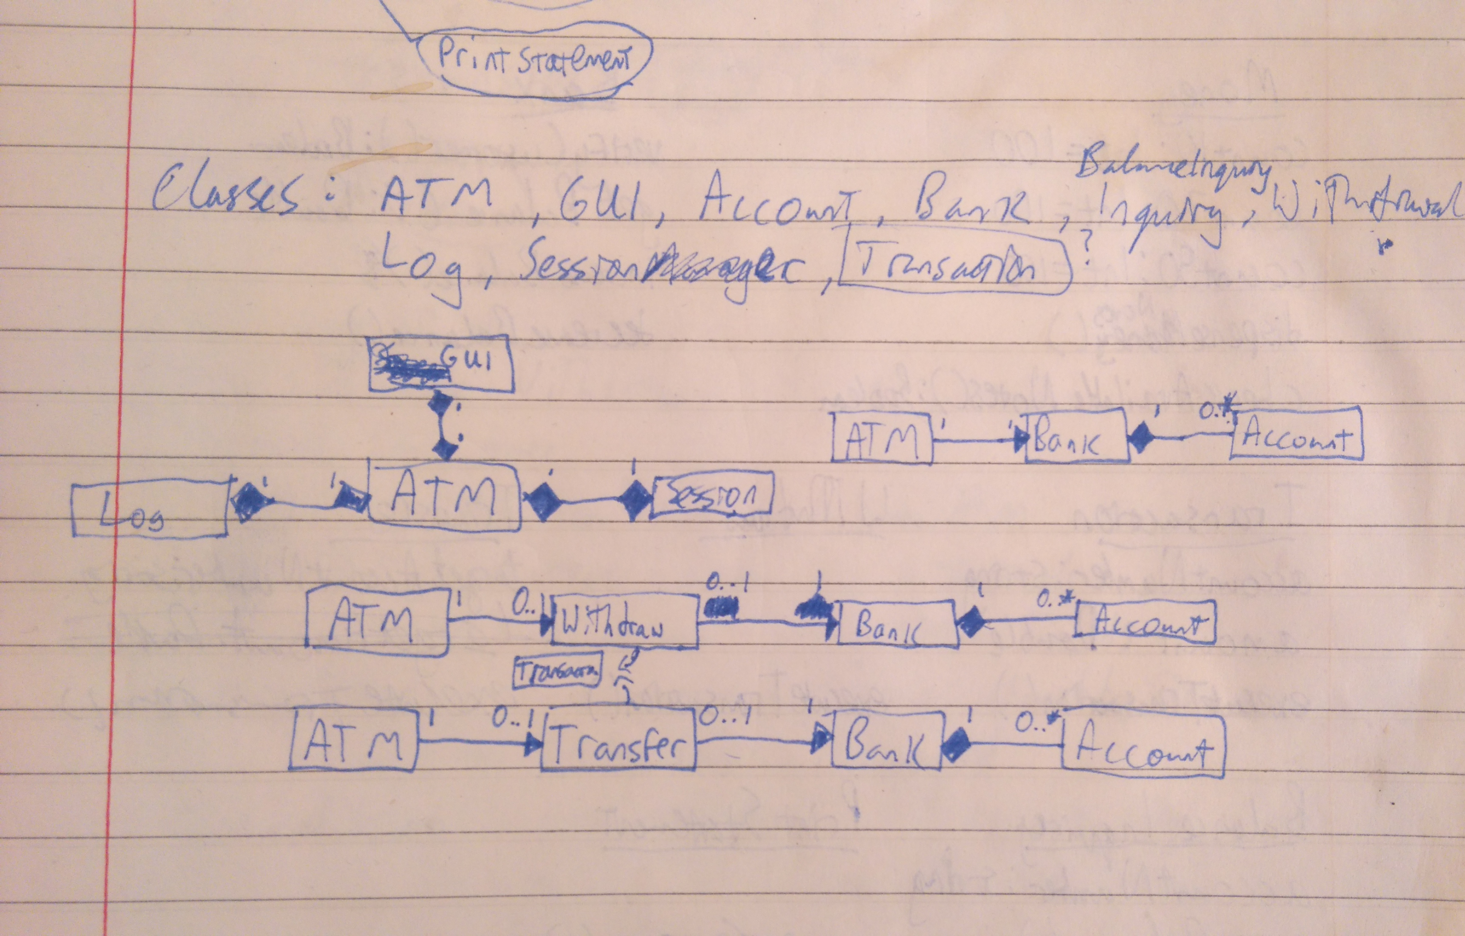

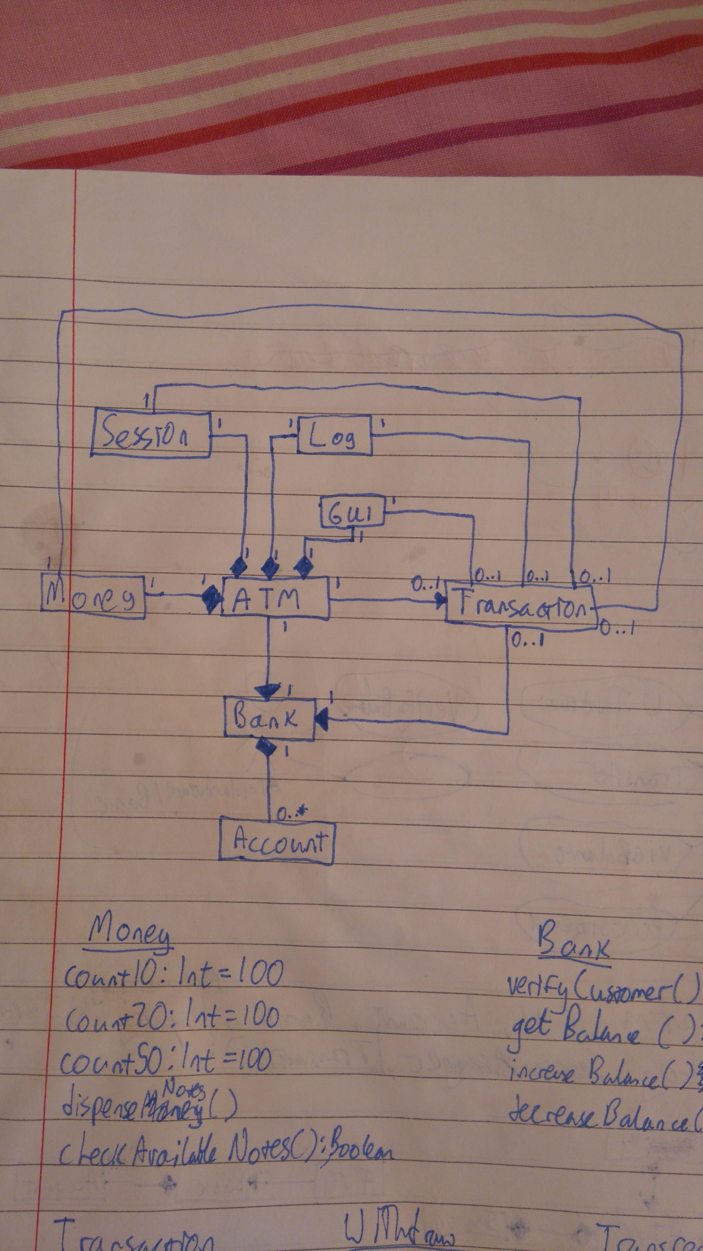

DESIGN BLUEPRINTS

Withdraw Sequence Diagram:
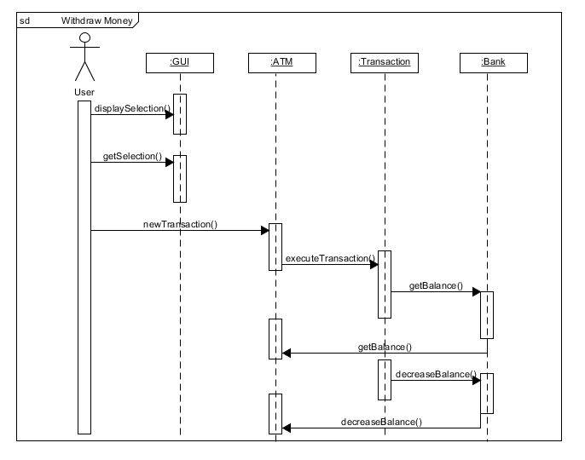
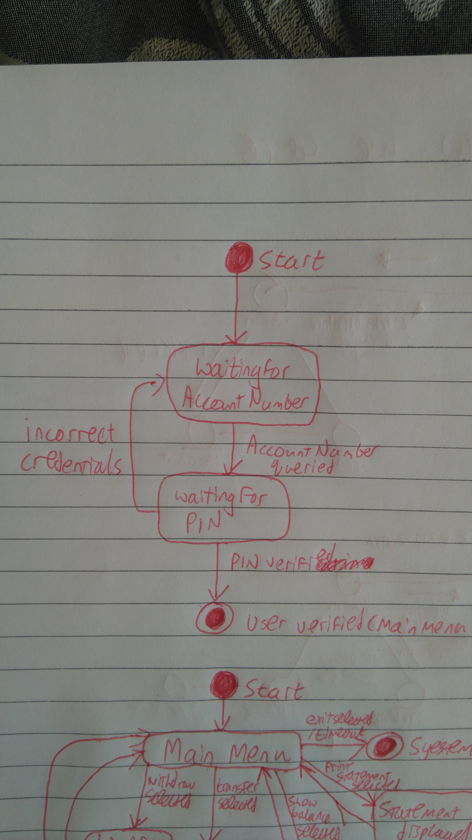
State Charts: Login:

Main Functionality:

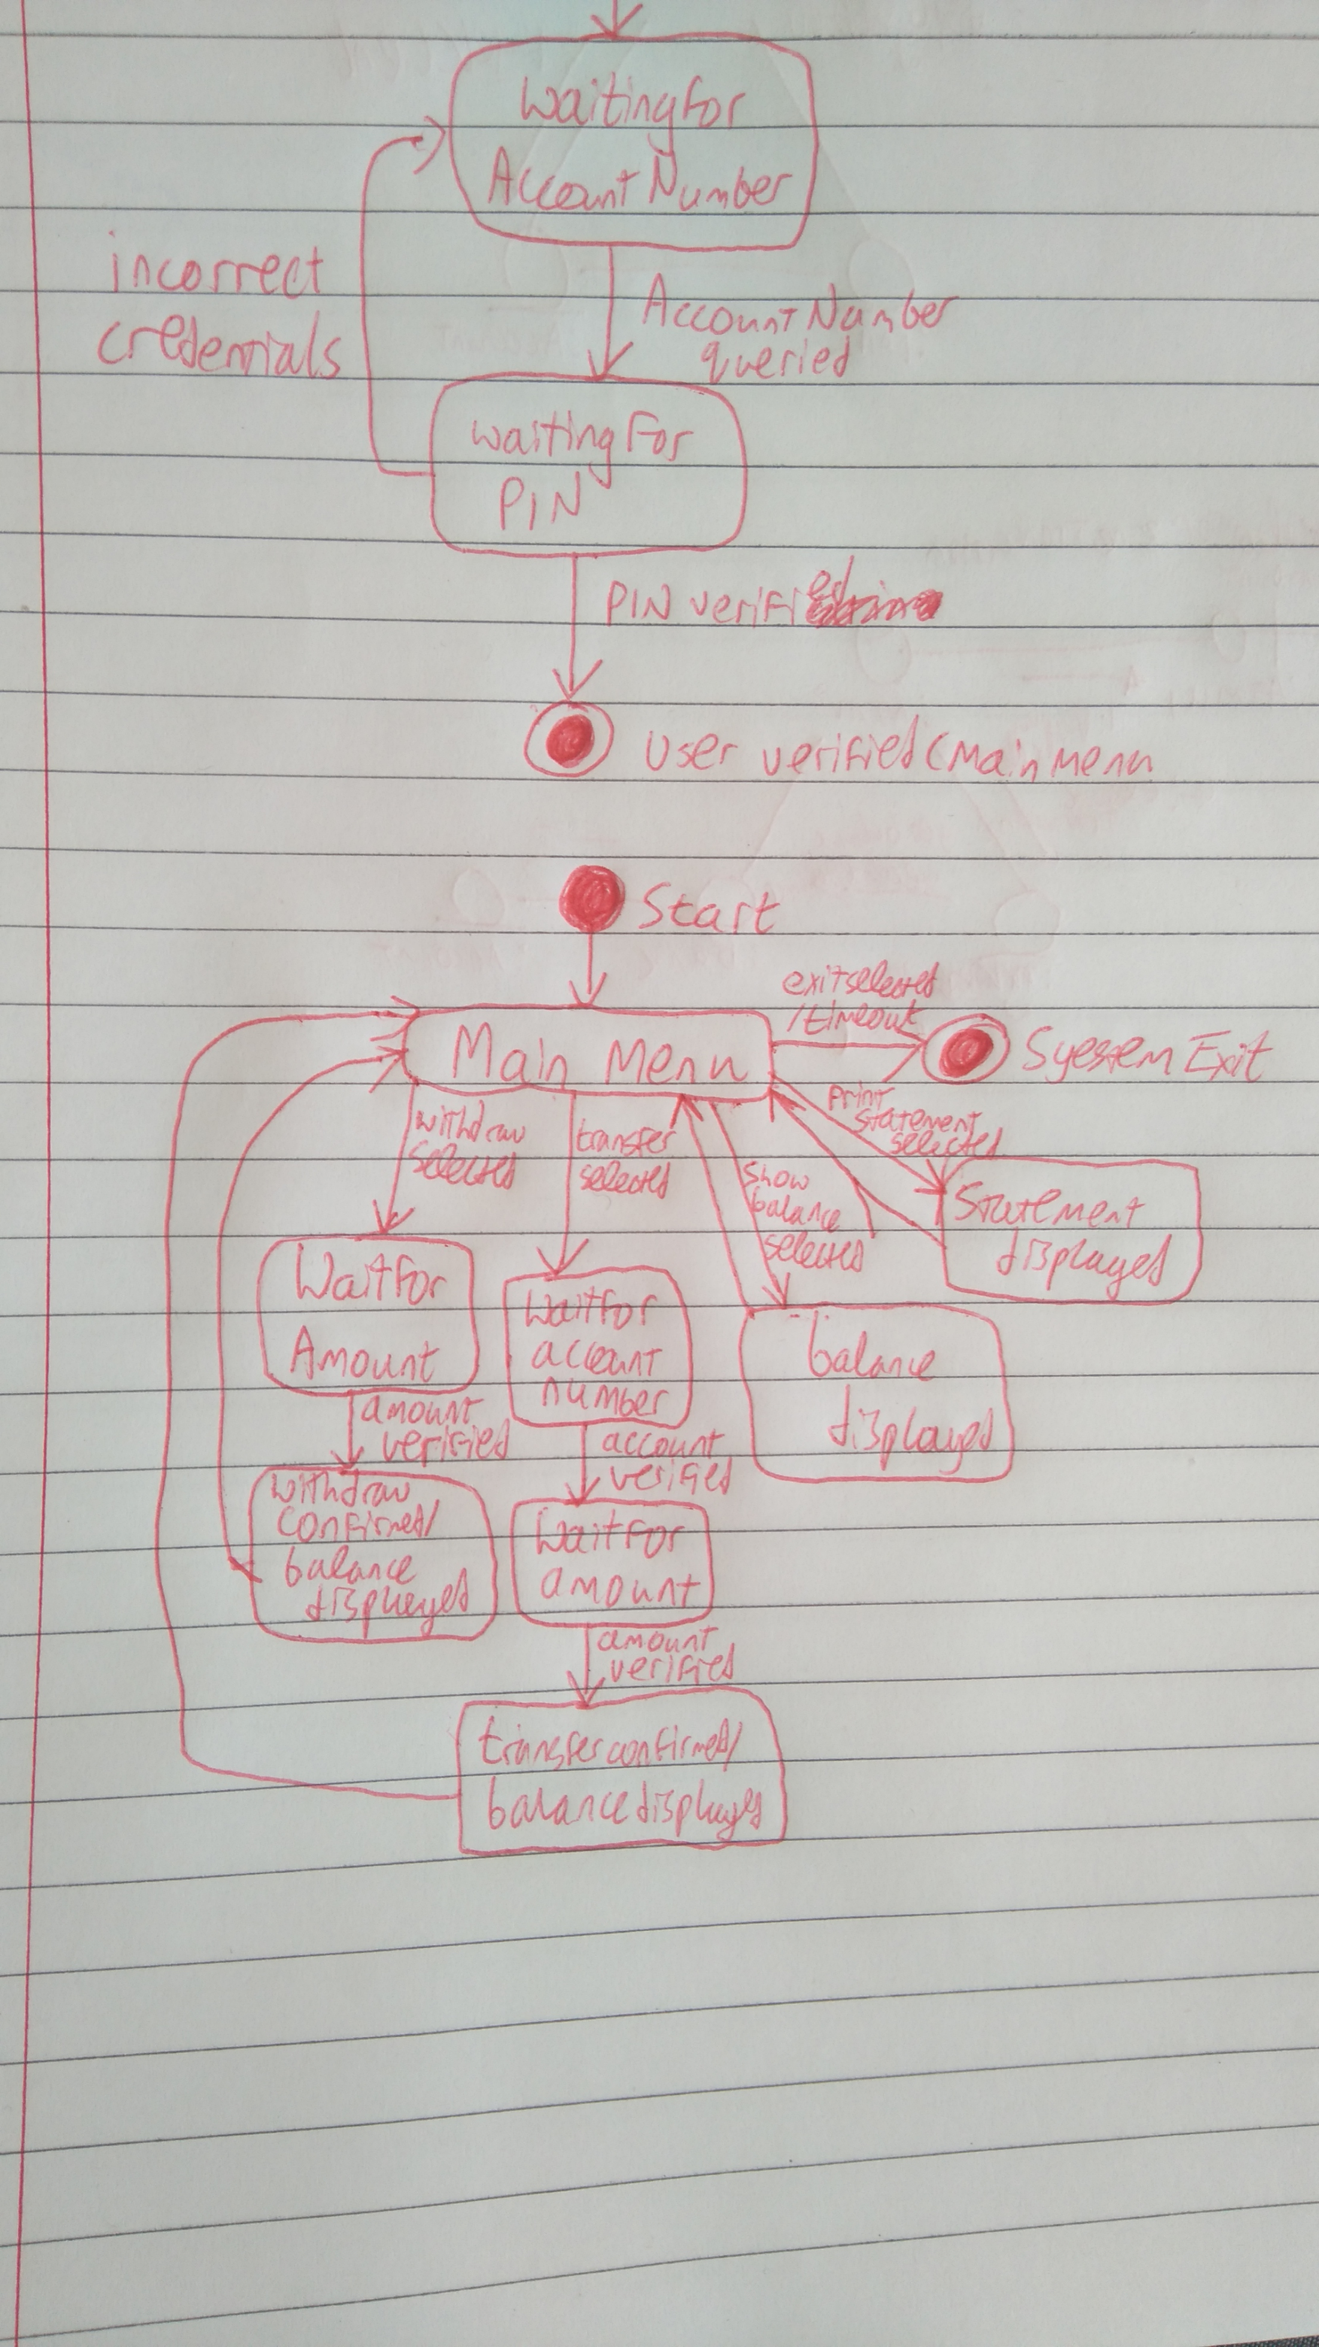

Design Class Diagram:



